ASSIGNMENT

1.Create a blog or website using Blogspot and WordPress.

Customize the theme design and post new article with 500

words.

LINK FOR BLOGSPOT: <https://vijaythalapathyupnext.blogspot.com/2023/10/elite-fitness-centre.html>

LINK FOR WORDPRESS:

<https://wordpress.com/post/consolecorner415.wordpress.com/5>

2. Create a New Facebook Business Page and post one

social media poster for your brand.

LINK: <http://facebook.com/workoutfitnesscenter174>

3. Create and design a social media advertisement poster

using canva.

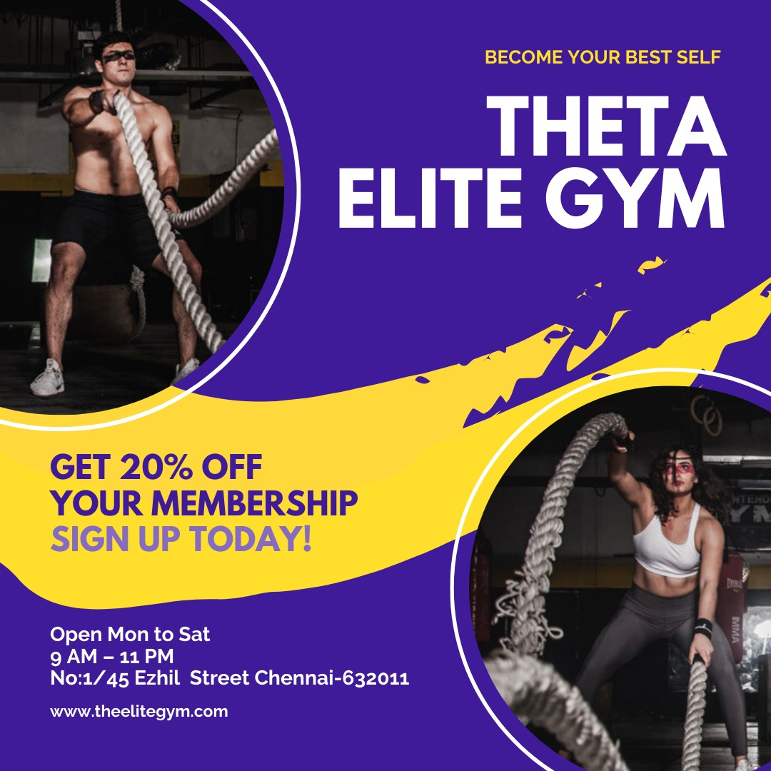

4. Create email newsletter design using MailChimp or canva

tool.

